Red Mic, LLC

Corporate Culture Data Analysis

## Presented by

Kyle Tolliver

Jesse Gibbons

Richard Kung

Shane Mecham

Benjamin Hinchman

# Contents

I. Analysis Overview 3

II. Equitable Pay Analysis 3

III. Employee Longevity Clusters 4

IV. Diversity 4

V. Employee Satisfaction and Engagement Survey Analysis 6

VI. Conclusion and Caveats 7

VII. Python Notebooks 7

1. Analysis Overview

This company wanted us to answer different questions using data analytics. We were able to get graphs and statistical test results to have with the analysis. We were able to answer the questions given to me using the data given to us. All the analytics were done using the programming language python and the additional libraries.

1. Equitable Pay Analysis

All of the positions that have only one employee where assumed to be receiving equitable pay as there is no comparable pay for these positions.

Sex : For the hourly positions the pay is flat across the board, for the salaried positions they vary by very small amounts however that could be due to raises accrued or other factors. Areas that need a more indepth analysis would be IT Support to see if females are getting paid less than males and Software Engineer's to see if males are getting paid less than females.

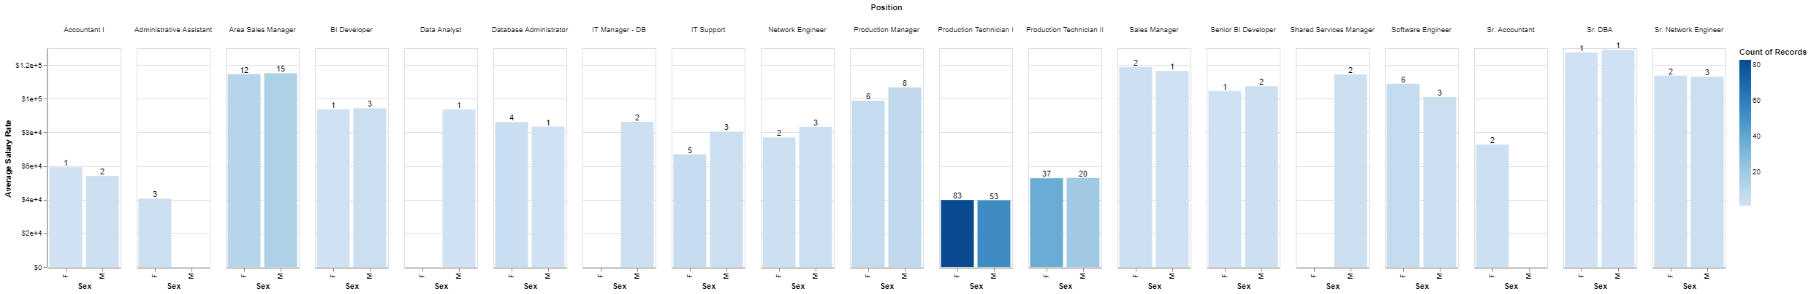

Race : Senior BI Developers, Shared Services Manager, Sr. Accountant, Sr. DBA, Sr. Network Engineer, and Network Engineer are the only positions that will not require a more in depth analysis as all employees are paid the same amount. Areas that drastically need evaluation are IT Manager - DB where one employee is being paid three times more than his counterpart, IT Support where white employees appear to be paid more, Production Manager has no two races getting paid the same way, both groups of Production Technicians has no two races getting paid the same way.

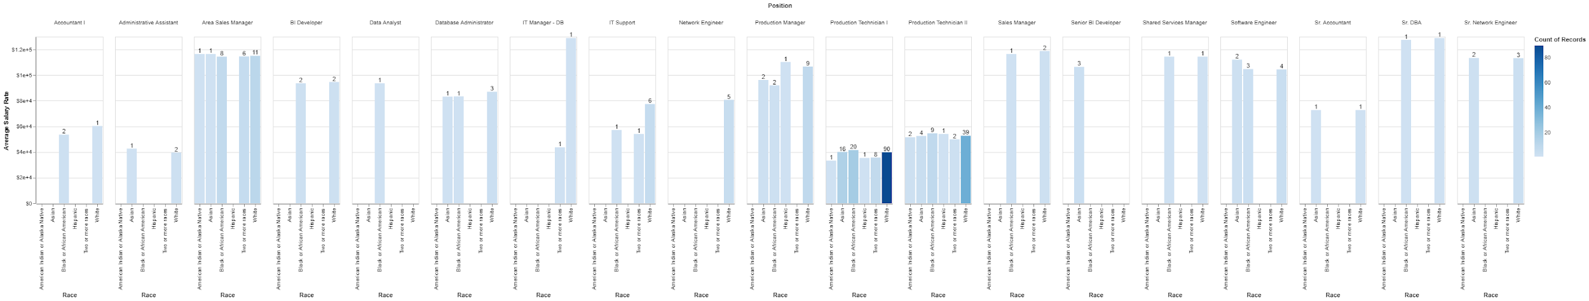

Marital Status : Area Sales Manager, Senior BI Developer, Shared Services Manager, and Sr Accountant don't appear to have equitable pay issues. All other positions that contain more than one position need a case-by-case analysis to ensure equitable pay.

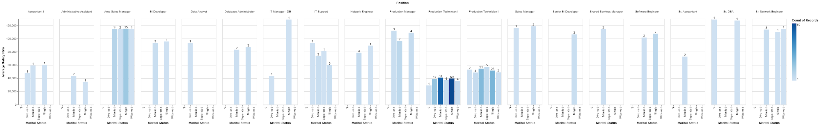

1. Employee Longevity Clusters

Our analysis of the longevity of employees shows that a majority of our current employees have been here for less than two years. If we look at all employees, we can see that a majority of our employees leave at about the 6th-7th year mark. Our longest tenured employee currently is at the 7th year mark, while the longest an employee has been here was over 14 years. According to the graph, our main turnover begins to happen at the 5th year of employment, and peaks at the 7th year.

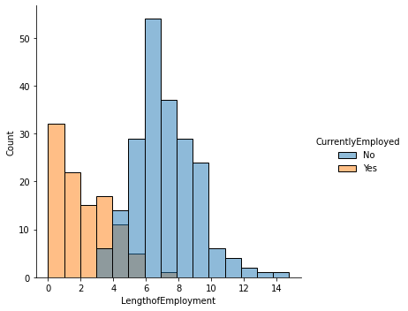

1. Diversity

|  |  |  |
| --- | --- | --- |
| Ethnicity | Massachusetts Diversity (%) | Company Diversity (%) |
| White | 81.3 | 62.3 |
| Black or African American | 8.8 | 18.4 |
| Asian | 6.9 | 11.0 |
| Hispanic | 11.9 | 1.3 |
| American Indian, Alaska Native, Hawaiians | 0.6 | 1.3 |
| Two or more races | 2.4 | 5.9 |

The company being in MA, it has been doing really well in diversity. The white population is at 81.3% in MA, the company has managed to lower its white population workforce to 62.2%. This help other races get more opportunity to work in the company.

We also have a good amount of each gender, 0.571 (57.1%) of Females, and 0.429 (42.9%) of Males. This is a very impressive job we have done to ensure women and men have equal opportunities.

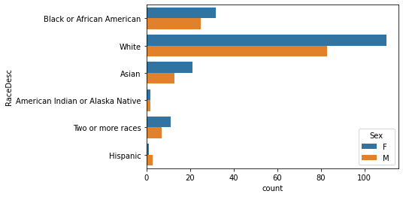

1. Employee Satisfaction and Engagement Survey Analysis

There does appear to be a correlation between the new Employee Satisfaction survey results and the number of years an employee has been working. From the second year to the fourth year of employment, employee satisfaction decreases. Then, employee satisfaction increases until about the seventh year of employment.

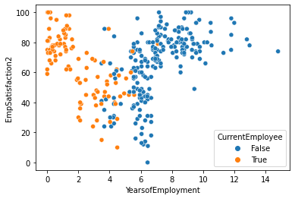

There does not appear to be any correlation between the Engagement survey results and the number of years an employee has been working.

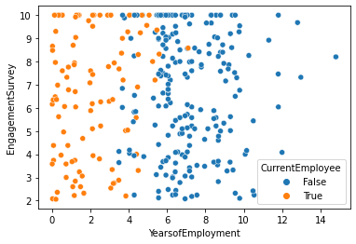

There does not appear to be any correlation between the old Employee Satisfaction survey results and the number of years an employee has been working.

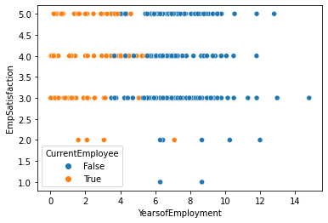

1. Conclusion and Caveats

We were able to dive deep into the code and analyse the data to make inferences. We were able to create graphs to help answer your questions. We used the method of machine learning called clustering. As a team we split up the questions and focused on the question. We found this effective because each of us mastered one question. We also had a team member compile all the analyzes into one analysis. We hope this analysis answers all your questions.

1. Python Notebooks

Below are Github Gist links to the notebooks we used during this case study:

<https://colab.research.google.com/gist/kctolli/d92095e5b68dee1609359563002bb4c5/main-2.ipynb>